Ideation Phase
Empathize & Discover

Date | 08 October 2026
Team ID | SWUID2026235621
Project Name | iMovies - Cinema Booking Platform
Maximum Marks | 4 Marks

Empathy Map Canvas:
Understand the needs, frustrations, and behaviors of moviegoers and cinema enthusiasts seeking seamless showtime discovery and instant ticket booking through iMovies - Cinema Booking Platform.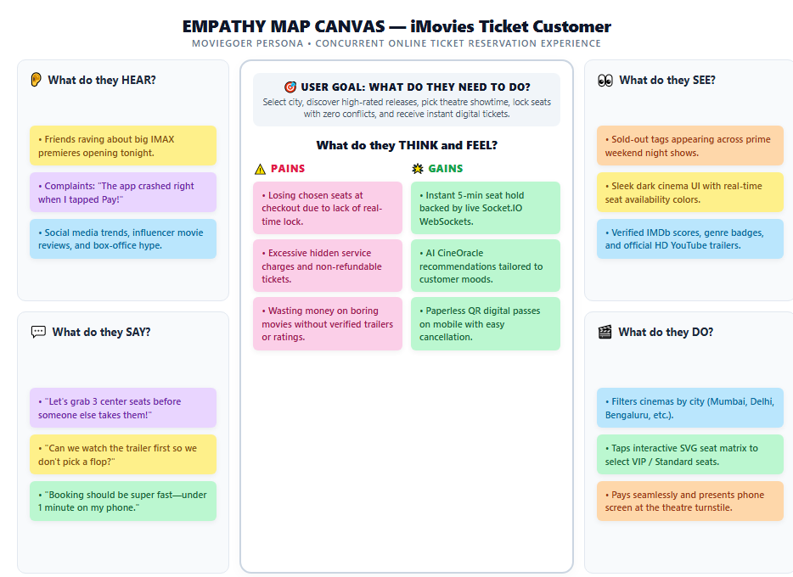

Reference: https://www.mural.co/templates/empathy-map-canvas

